Preparation of Papers for JACoW Conferences*
J. Poole, C. Petit-Jean-Genaz, CERN, Geneva, Switzerland
C.E. Eyberger#, ANL, Argonne, IL 60439, USA

Abstract
Many conference series have adopted the same standards for electronic publication and have joined the Joint Accelerator Conference Website (JACoW) collaboration [1] for the publication of their proceedings. This document describes the common requirements for the submission of papers to these conferences. Please consult individual conference information for page limits, method of electronic submission, etc. It is not intended that this should be a tutorial in word processing; the aim is to explain the particular requirements for electronic publication at these conference series.

Submission of Papers
Each author should submit the PostScript and all of the source files (text and figures), to enable the paper to be reconstructed if there are processing difficulties.

Manuscripts
Templates are provided for recommended software and authors are advised to use them. Please consult the individual conference help pages if questions arise.

General Layout
These instructions are a typical implementation of the requirements. Manuscripts should have:
- Either A4 (21.0 cm × 29.7 cm; 8.27 in × 11.69 in) or US letter size (21.6 cm × 27.9 cm; 8.5 in × 11.0 in) paper.
- Single-spaced text in two columns of 82.5 mm (3¼ in) with 5.3 mm (0.2 in) separation. Newer versions of Word (2007, 2010) have a default spacing of 1.5 lines; authors must change this to 1 line.
- The text located within the margins specified in Table 1 to facilitate electronic processing of the PDF file.

Table 1: Margin Specifications
Margin | A4 Paper | US Letter Paper
Top | 37 mm (1.46 in) | 0.75 in (19 mm)
Bottom | 19 mm (0.75 in) | 0.75 in (19 mm)
Left | 20 mm (0.79 in) | 0.79 in (20 mm)
Right | 20 mm (0.79 in) | 1.0 in (26 mm)

The layout of the text on the page is illustrated in Fig. 1. Note that the paper’s title and the author list should be the width of the full page. Tables and figures may span the whole 170 mm page width, if desired (see Fig. 2), but full-width figures should be placed at either the top or bottom of a page to ensure proper flow of the text (Word templates only).

*Work supported by … THIS INFORMATION MUST BE WITHIN
#cee@aps.anl.gov THE TEXT & COLUMN MARGINS

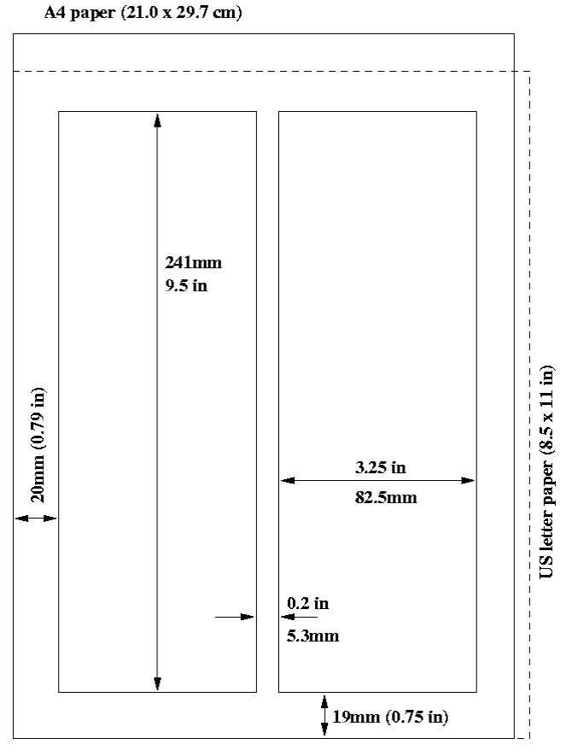
Figure 1: Layout of papers.
Fonts
In order to produce good Adobe Acrobat PDF files, authors using a LaTeX template are asked to use only Times (in roman (standard), bold or italic) and symbols from the standard PostScript set of fonts. In Word use only Symbol and, depending on your platform, Times or Times New Roman fonts in standard, bold or italic form.

Title and Author List
The title should use 14 pt bold uppercase letters and be centered on the page. Individual letters may be lowercase to avoid misinterpretation (e.g., mW, MW). To include a funding support statement, put an asterisk after the title and a footnote at the bottom of the first column on page 1; in LaTeX use \thanks.
The names of authors, their organizations/affiliations and mailing addresses should be grouped by affiliation and listed in 12 pt upper and lowercase letters. The name of the submitting or primary author should be first, followed by the co-authors, alphabetically by affiliation.

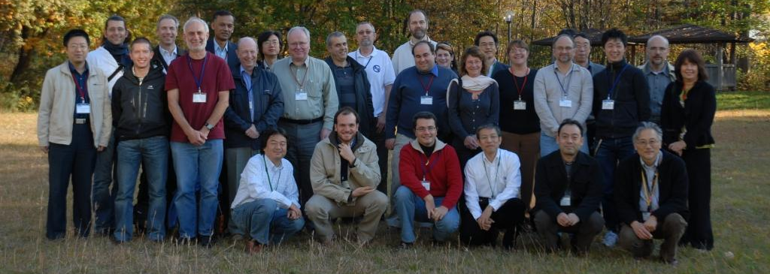
Figure 2: Example of a full-width figure showing the JACoW Team at their annual meeting in 2008. This figure is labeled with a multi-line caption which has to be justified, rather than centered.

Section Headings
Section headings should not be numbered. They should use 12 pt bold uppercase letters and be centered in the column. All section headings should appear directly above the text—there should never be a column break between a heading and the following paragraph.

Subsection Headings
Subsection headings should not be numbered. They should use 12 pt italic letters and be left aligned in the column. Subsection headings should appear directly above the text—there should never be a column break between a subheading and the following paragraph.
Third-level Heading is a new style, but authors must bold text themselves; it should be used sparingly. It is a run-in heading in 10 pt bold font followed by regular text.

Paragraph Text
Paragraphs should use 10 pt font and be justified (touch each side) in the column. The beginning of each paragraph should be indented approximately 3 mm (0.13 in). The last line of a paragraph should not be printed by itself at the beginning of a column nor should the first line of a paragraph be printed by itself at the end of a column.

Figures, Tables and Equations
Place figures and tables as close to their place of mention as possible. Lettering in figures and tables should be large enough to reproduce clearly. Use of non-approved fonts in figures can lead to problems when the files are processed. LaTeX users – please be sure to use non bitmapped versions of Computer Modern fonts in equations (type 1 PostScript fonts are required and their use is described in the JACoW help pages [2]).
All figures and tables must be given sequential numbers (1, 2, 3, etc.) and have captions (10 pt font) placed below figures and above tables being described. Captions that are one line should be centered in the column, while captions that span more than one line should be justified. The LaTeX template uses the ‘booktabs’ package to format the tables
A simple way to introduce figures into a Word document is to place them inside a table with no borders. This is done in Word as follows:
- Insert a continuous section break.
- Insert two empty lines (makes later editing easier).
- Insert another continuous section break.
- Click between the two section breaks and Format → columns → Single.
- Table → Insert single column, two row table.
- Paste the figure in the first row and adjust the size as appropriate.
- Paste/Type the caption in the second row and apply figure caption style.
- Table → Table properties → Borders and shading → None.
- Table → Table properties → Alignment → Center.
- Table → Table properties → Text wrapping → None.
- Remove blank lines from in and around the table.
- If necessary play with the cell spacing and other parameters to improve appearance.
If a displayed equation needs a number, place it flush with the right margin of the column (see Eq. 1). The equation itself should be centered, if possible. Units should be written using the roman (standard) font, not the italic font:
$C_{B}=\frac{q^{3}}{3ε_{0}\text{mc}}=3\text{.}\text{54}μeV/T$. (1)

References
All bibliographical and web references should be numbered and listed at the end of the paper in a section called “References.” When citing a reference in the text, place the corresponding reference number in square brackets [3]. A URL may be included as part of a reference (no period after), but its hyperlink should NOT be added.

Footnotes
Footnotes on the title and author lines may be used for acknowledgments, affiliations and e-mail addresses. A nonnumeric sequence of characters (*, #, †, ‡) should be used. All other footnotes should be included in the reference section and use the normal numeric sequencing.
Word users—DO NOT use Word’s footnote feature (Insert, Footnote) to insert footnotes, as this will create formatting problems. Instead, insert footnotes manually in a text box at the bottom of the first column with a line at the top of the text box to separate the footnotes from the rest of the paper’s text. The easiest way to do this is to copy the text box from the JACoW template and paste it into your own document. These “pseudo footnotes” in the text box should only appear at the bottom of the first column on the first page [4].

Acronyms
Acronyms should be defined the first time they appear.

Styles
Table 2 summarizes the fonts and spacing used in the styles of a JACoW template (these are implemented in the LaTeX class file).

Page Numbers
DO NOT include any page numbers. They will be added when the final proceedings are produced.

Templates
Templates and examples can be retrieved through Web browsers like Firefox and Internet Explorer by saving to disk. See your local documentation for details about how to do this [5].
Template documents for the recommended word processing software are available from the JACoW Website and exist for LaTeX, Microsoft Word (Mac and PC) and OpenOffice for US letter and A4 paper sizes.
Use the correct templates for your paper size and version of Word. Do not transport Microsoft Word documents across platforms, e.g., Mac↔PC. When saving a Word 2010 file (PC), be sure to click ‘Embed fonts’ in the Save options. Fonts are embedded by default when printing to Postscript or PDF on Mac OSX.
Please see the information and help files for authors on the JACoW.org web site for instructions on how to install templates in your Microsoft templates folder.

Checklist for electronic Publication
- Use only Times or Times New Roman (standard, bold or italic) and Symbol fonts for text—10 pt minimum except References, which can be 9 pt or 10 pt.
- Figures use Times or Times New Roman (standard, bold or italic) and Symbol fonts when possible—6 pt minimum.
- Check that the PDF file prints correctly according to instructions on the conference web site.
- Check that there are no page numbers.
- Check that the margins on the printed version are within ±1 mm of the specification.
- LaTeX users can check their margins by invoking the boxit option.
Table 2: Summary of Styles
Style | Font | Space  Before | Space  After
Heading 1, PaperTitle | 14 pt  Uppercase except for  required lowercase letters  Bold | 0 pt | 3 pt
Author List | 12 pt  Upper- and lowercase | 9 pt | 12 pt
Heading 2, Section  Heading | 12 pt  Uppercase  Bold | 9 pt | 3 pt
Heading 3, Subsection  Heading | 12 pt  Initial caps  Italic | 6 pt | 3 pt
Third-level Heading | 10 pt  Initial cap, Bold | 6 pt | 0 pt
Figure  Caption | 10 pt | 3 pt | 6 pt
Table  Caption | 10 pt | 3 pt | 3 pt
Equation | 10 pt base font | 12 pt | 12 pt
Reference | 10 pt, justified with  0.25” hanging indent | 0 pt | 0 pt

acknowledgment
Any acknowledgment should be in a separate section directly preceding the References section.

References
[1] C. Petit-Jean-Genaz and J. Poole, “JACoW, A Service to the Accelerator Community,” EPAC’04, Lucerne, July 2004, THZCH03, p. 249 (2004); http://www.JACoW.org.
[2] A. Name et al., Phys. Rev. Lett. 25 (1997) 56.
[3] A.N. Other, “A Very Interesting Paper,” EPAC’96, Sitges, June 1996, MOPCH31, p. 7984 (1996); http://www.JACoW.org {no period after URL}
[4] F.E. Black et al., This is a Very Interesting Book, (New York: Knopf, 2007), 52.
[5] G.B. Smith et al., “Title of Paper,” MOXAP07, these proceedings.

